Organ Matching & Transplantation

In this project we are employing Blockchain Technology to manage hospital, donor and patient’s (user details). Hospitals are responsible to record all donors and user details and then look for match between donor and user and once matched found then alert will be sent to both users and donors. Both users and donor can track matched status by using their ID given by hospital peoples.

Different hospitals can sign up and then login to application to records all donor and user details.

In the past existing centralized servers were used to store all user details and this servers will be managed by admins who can have full access to database and they can tamper or view details very easily and there is no direct way for the users to know about data leakage or tamper. Centralized servers can be easily hack by attackers and can crash or steal data from servers and in such scenarios server will be down and services will be disturbed for the users.

To overcome from above issues all applications are migrating to decentralized Blockchain services as Blockchain has inbuilt support for data encryption and store each data as block or transaction and associate each block with unique hash code and while storing new Blocks it will verify hash code of all previous blocks and if data not tamper then it will result into same hash code and verification will get successful and if alter then verification get failed and due to this reason Blockchain will be consider as immutable.

Blockchain is known as decentralized which means Blockchain store data at multiple servers or node and if one server down then it can access services from other working nodes.

Blockchain manage all data using smart contract and this contract will be designed using Solidity programming. Smart contract contains function to save and get data from Blockchain. In propose work to manage hospital details we have designed following smart contracts function

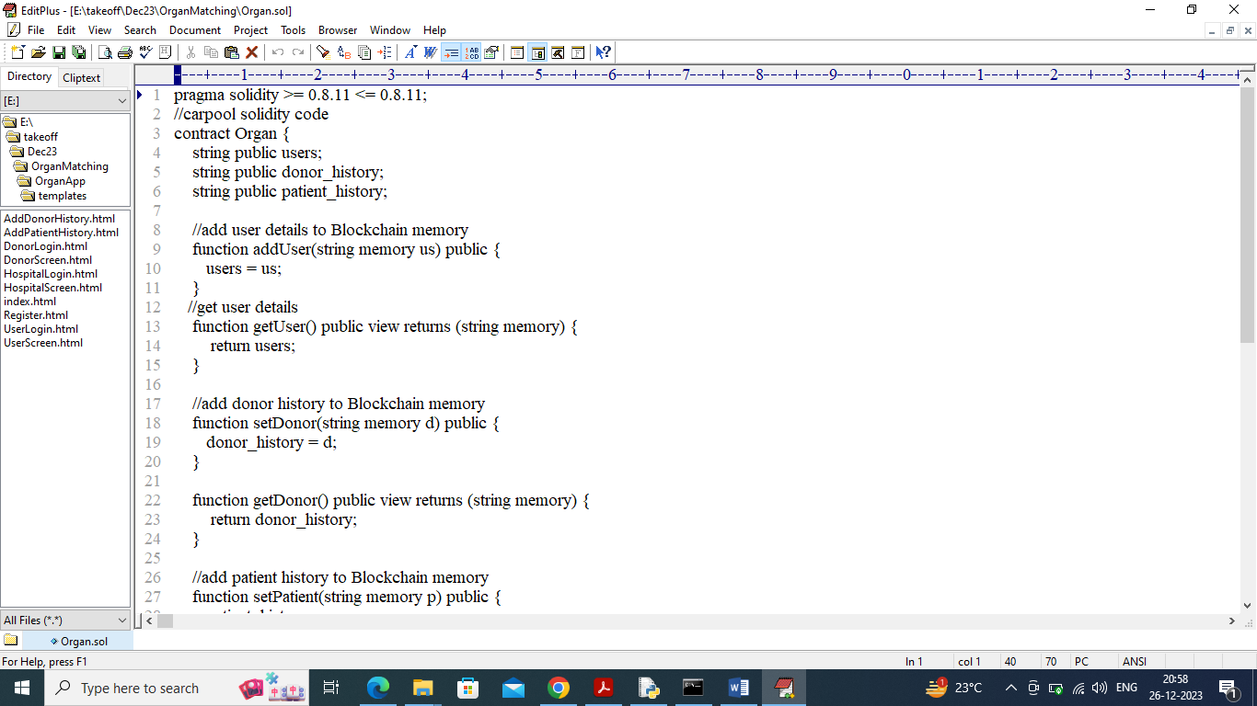

In above contract we have defined functions to save and get hospitals (users0, patients and donors. Now we need to deploy above contract in Blockchain Ethereum tool by following below steps

1. First go inside ‘hello-eth/node_modules/bin’ folder and then find and double click on ‘runBlockchain.bat’ file to get below screen
2. 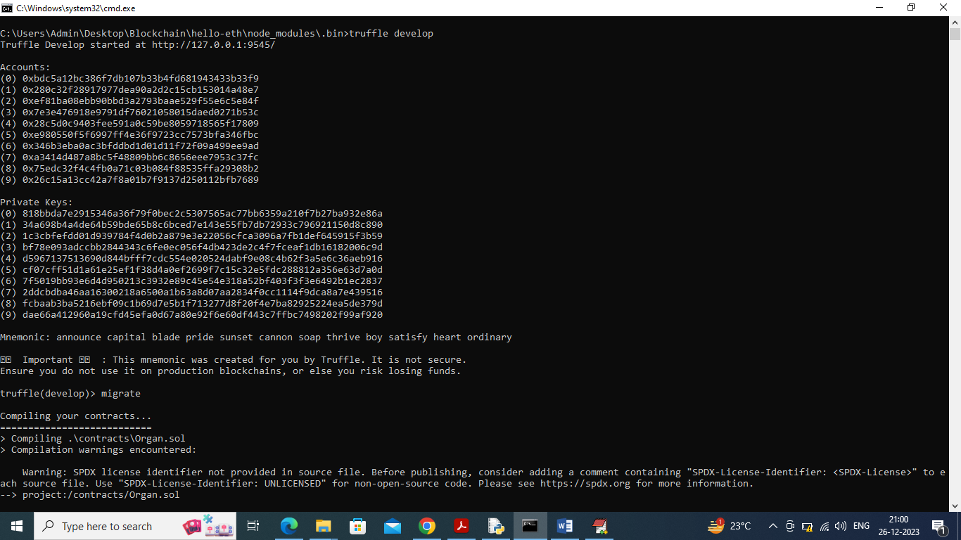
3. In above screen Ethereum started with default private keys and accounts and now type command as ‘migrate’ and press enter key to deploy contract and get below output
4. 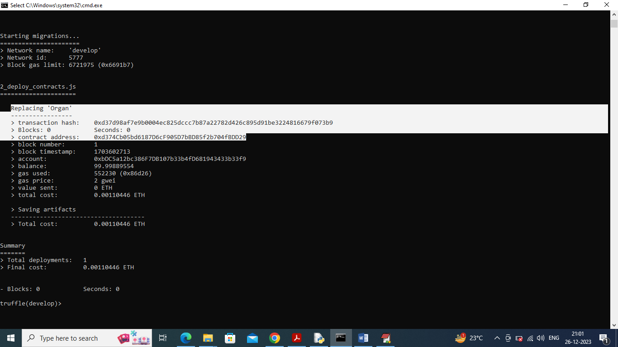
5. In above screen in white colour text can see ‘Organ’ contract deployed and we got contract address also and this address need to specify in python code to call Blockchain smart contracts functions.
6. 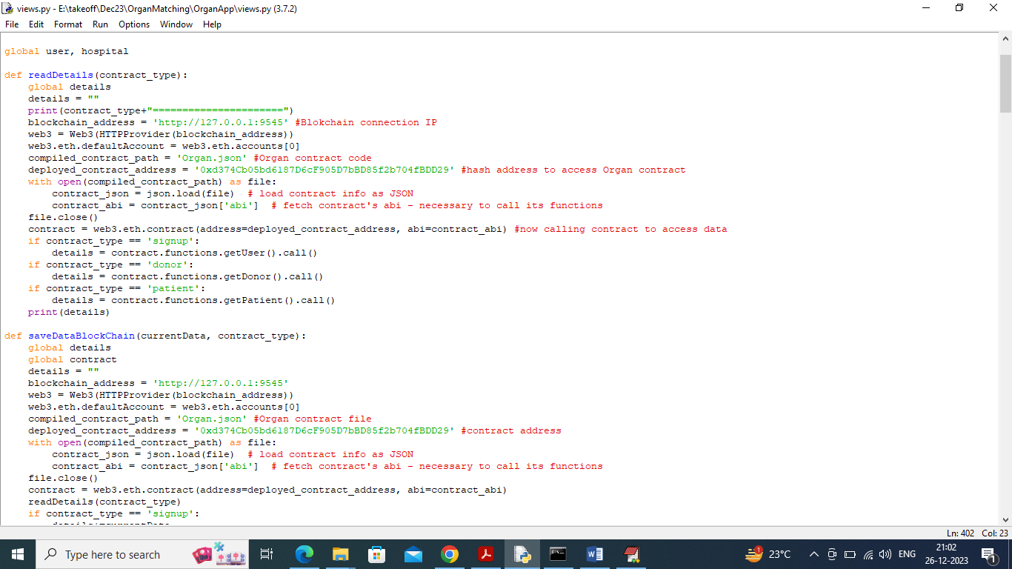
7. In above screen read red colour comments to know about Blockchain contract calling from python. In above screens already contract deployed and running in black console and let it run to execute code.

SCREEN SHOTS

To run project double click on ‘runServer.bat’ file to start python web server and get below page

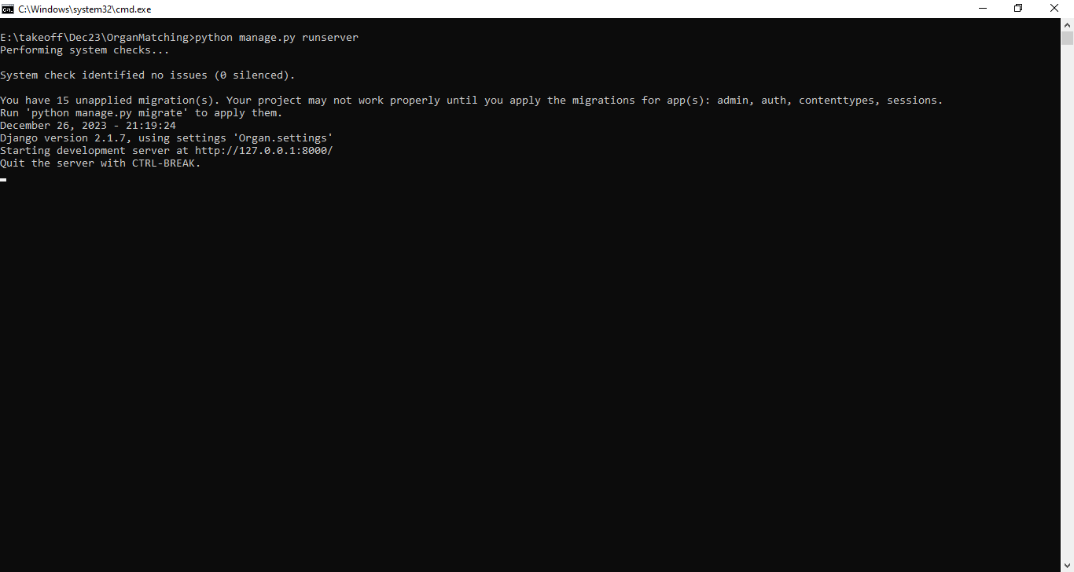

In above screen python server started and now open browser and enter URL as <http://127.0.0.1:8000/index.html> and press enter key to get below page

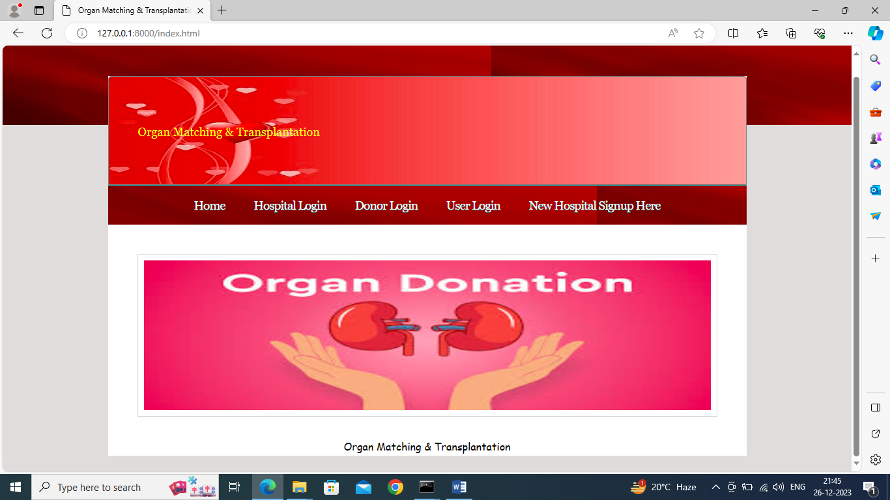

In above screen click on ‘New Hospital Signup Here’ link to get below page

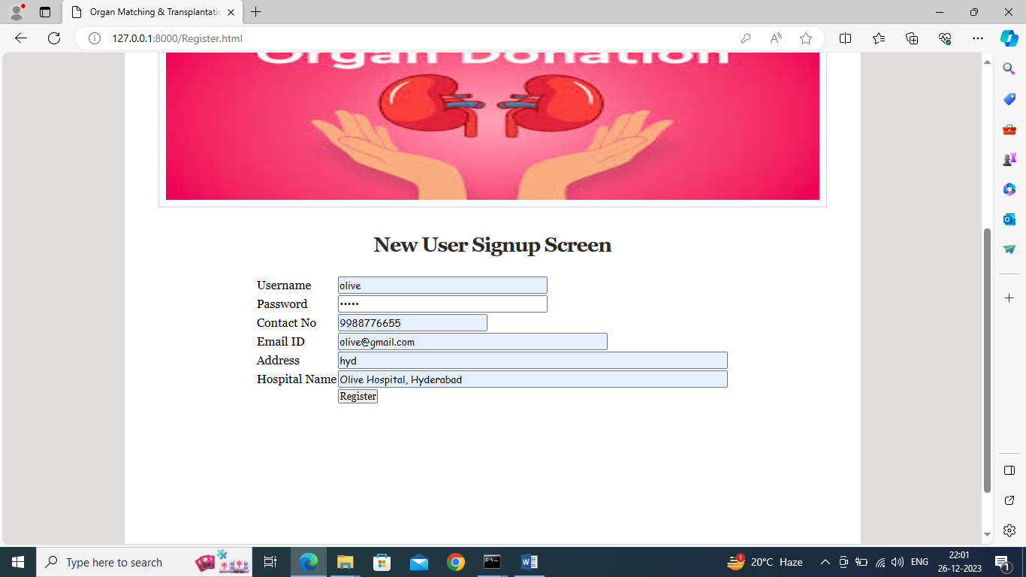

In above screen hospital is entering signup details and then press button to get below page

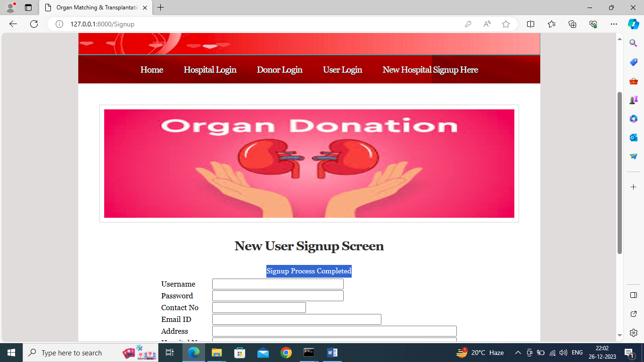

In above screen hospital sign up task completed and now click on ‘Hospital Login’ link to get below page

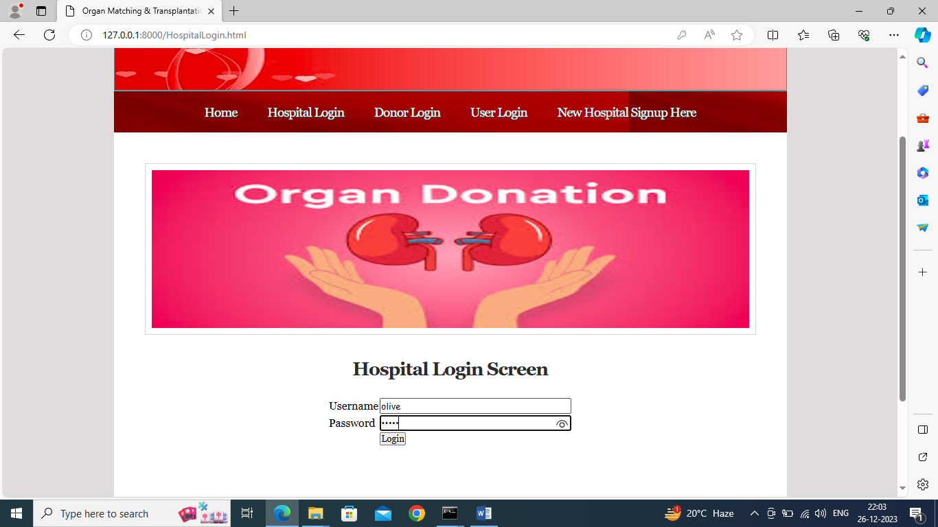

In above screen hospital is login and after login will get below page

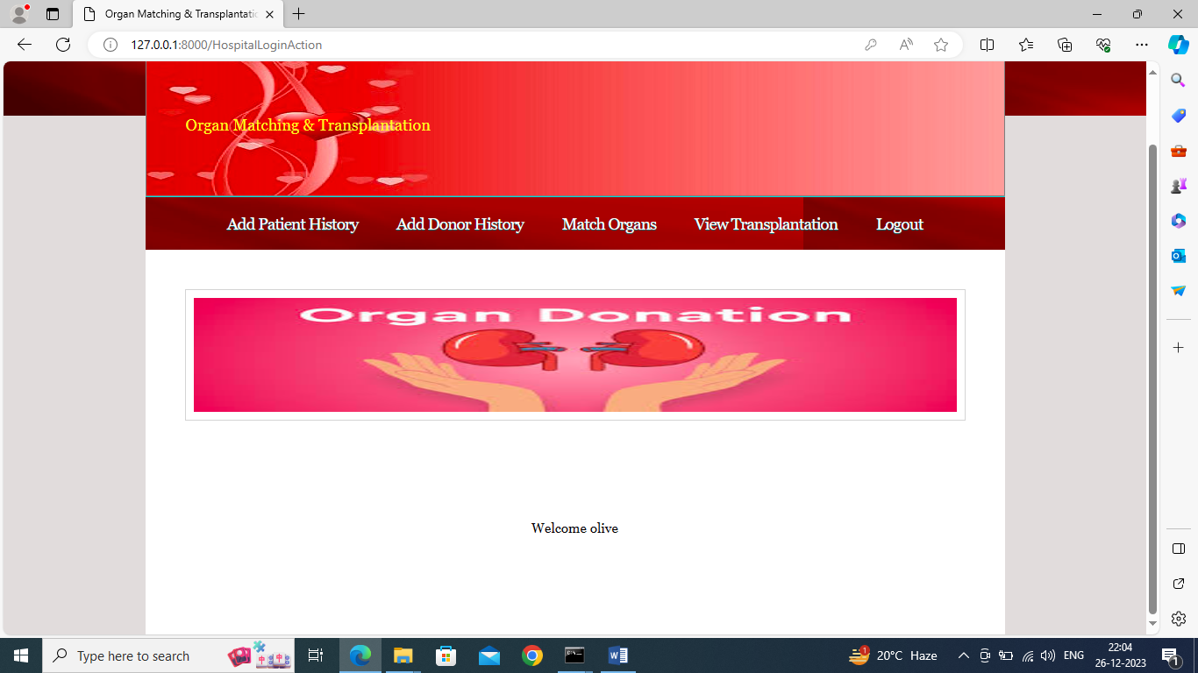

In above screen hospital can click on ‘Add Patient History’ link to add patient history for organs request

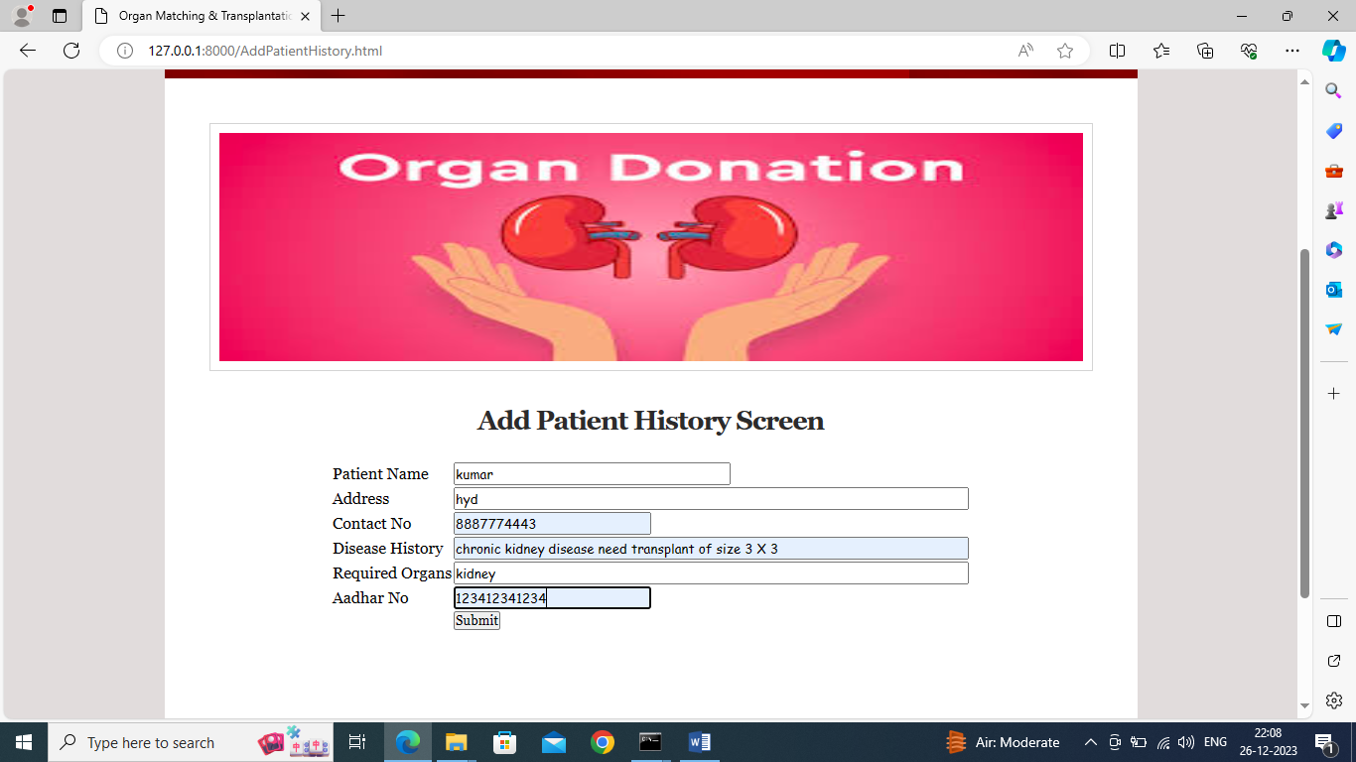

In above screen hospital can add patient details who need organs and all this details will saved inside Blockchain and will get below page

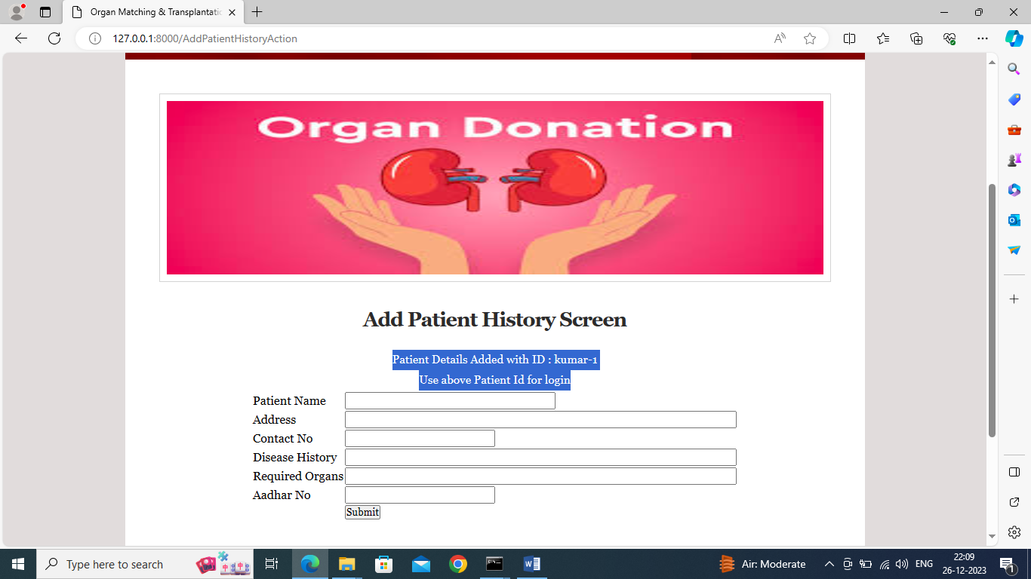

In above screen patient details added with ID and this id can be used by patients to track organ matching status and similarly you can add N numbers of patients and now click on ‘Add Donor History’ link to get below page

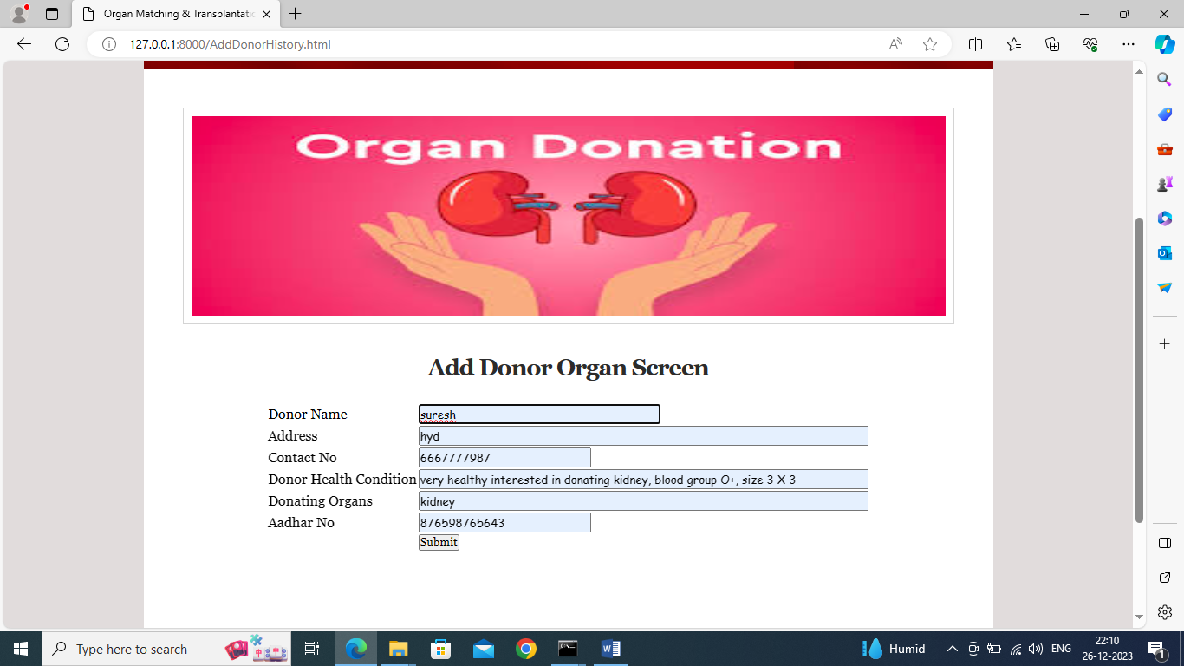

In above screen hospital adding donor details and now click on ‘Submit’ button to get below page

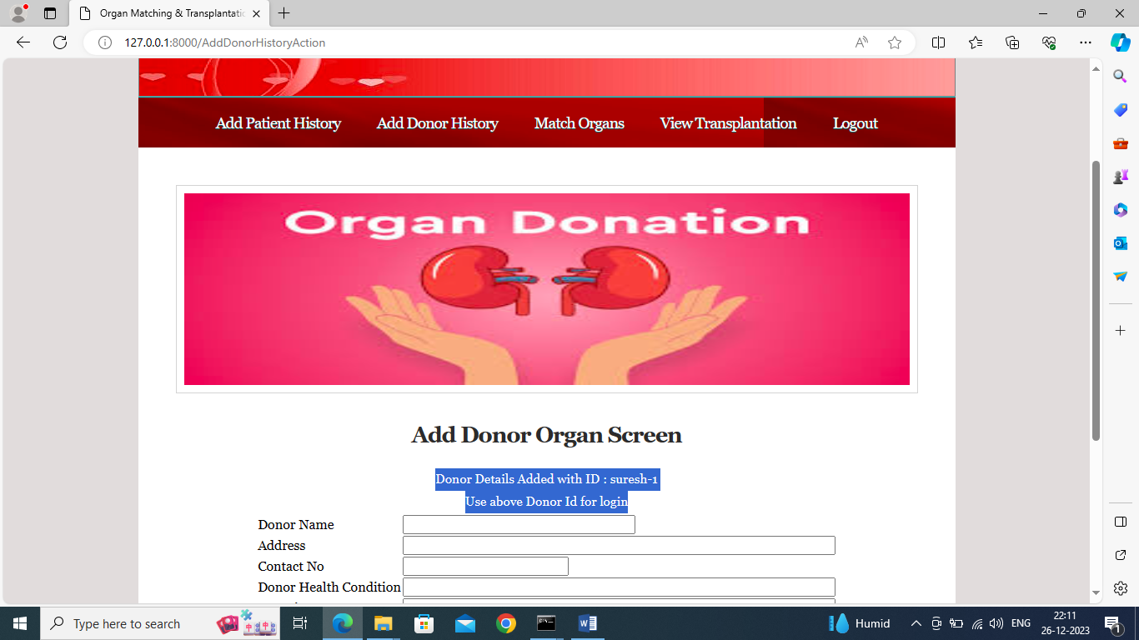

In above screen donating details added to Blockchain and donor can use above ID to track matching status and now click on ‘Match Organs’ link to get below page

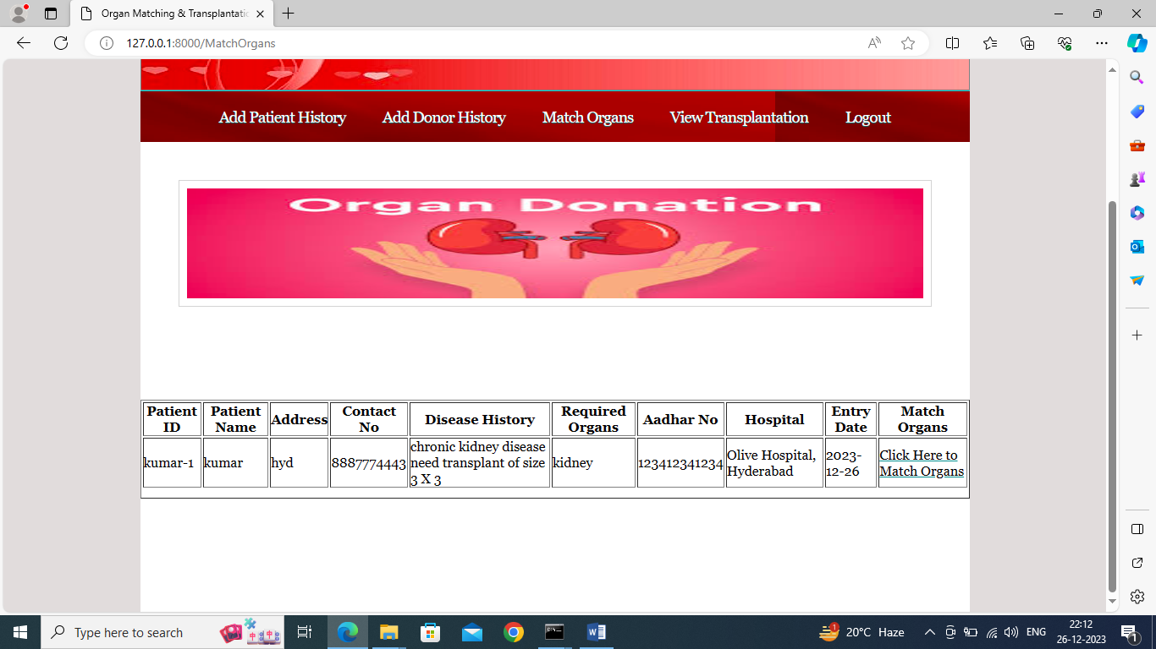

In above screen hospital can see all patients who need organs and can click on ‘Click Here to Match Organs’ link to view list of donors and then select desired donor

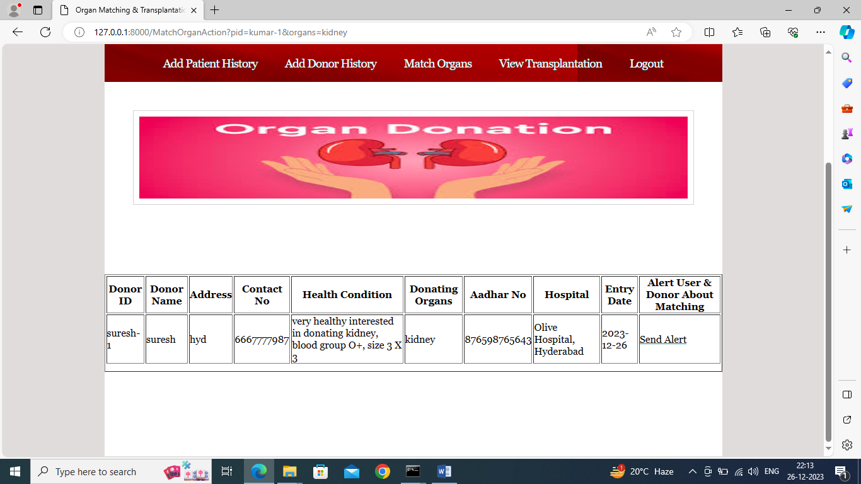

In above screen hospital can see one match and can click on ‘Send Alert’ link to send alert to both users and donors about match and then will get below output

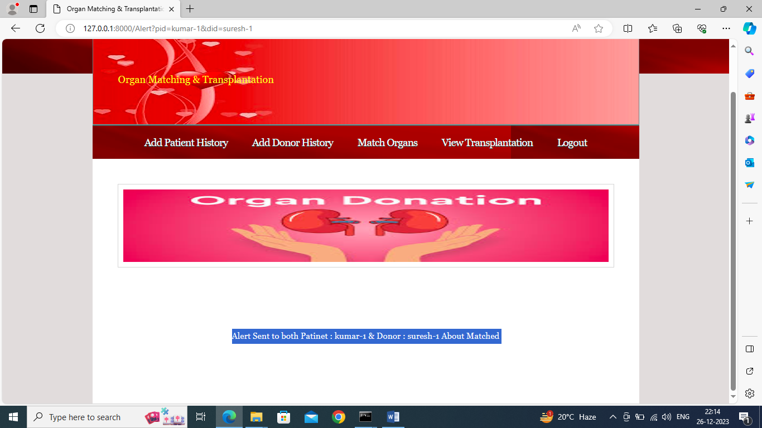

In above screen in blue colour text can see alert sent to both patients and donor and now hospital can click on ‘View Transplantation’ link to view all previous matches like below screen

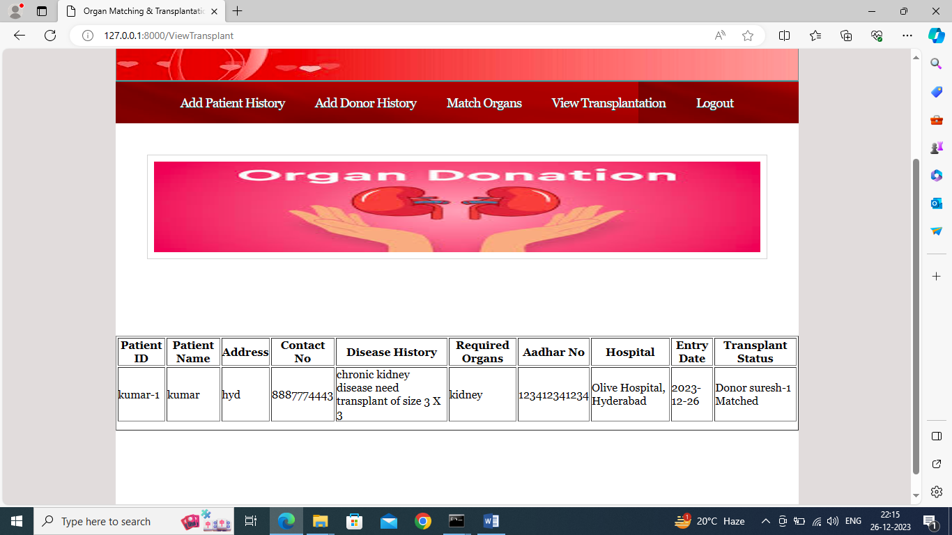

In above screen in last status column hospital can see which donor organ assigned to this patient. Now logout and login as donor to view status

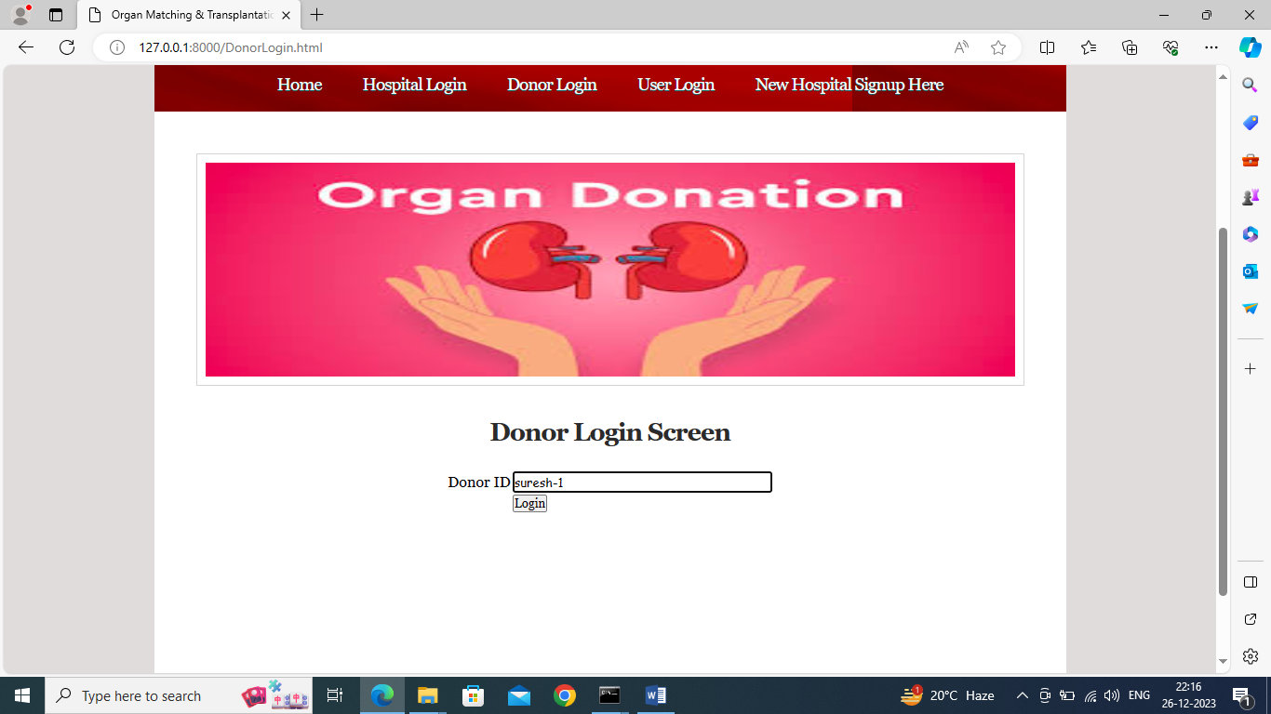

In above screen donor can enter his ID to get below page

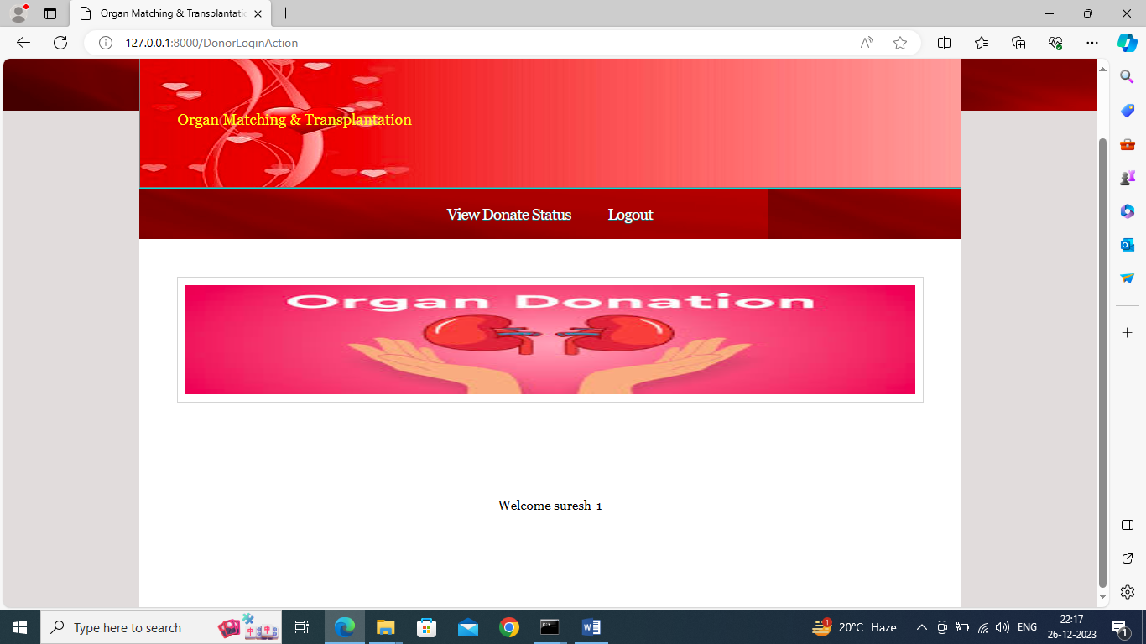

In above screen donor can click on ‘View Status’ link to get below organ matched status

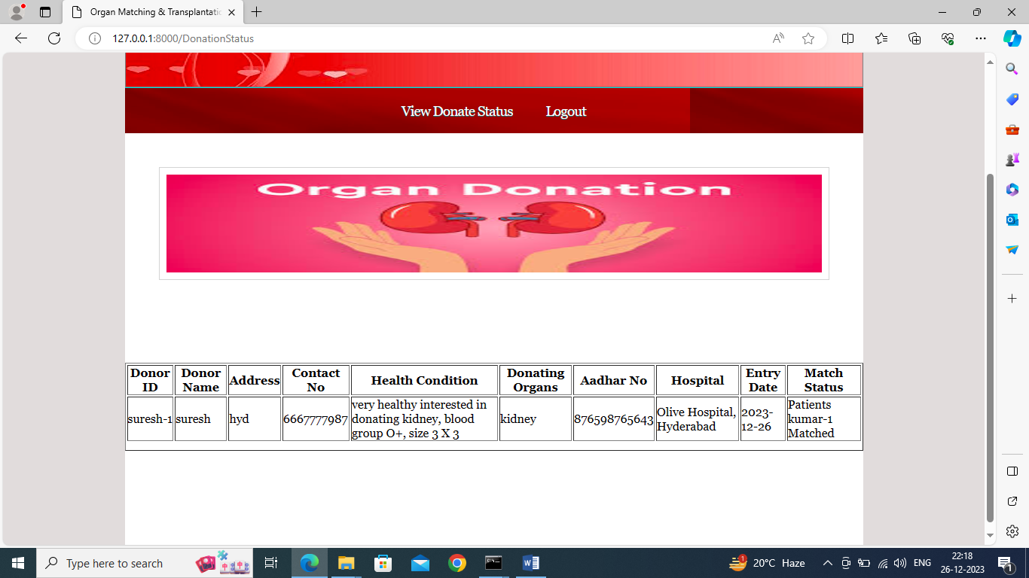

In above screen donor can see which patient is matched with his organ and now logout and login as ‘Patients or user’

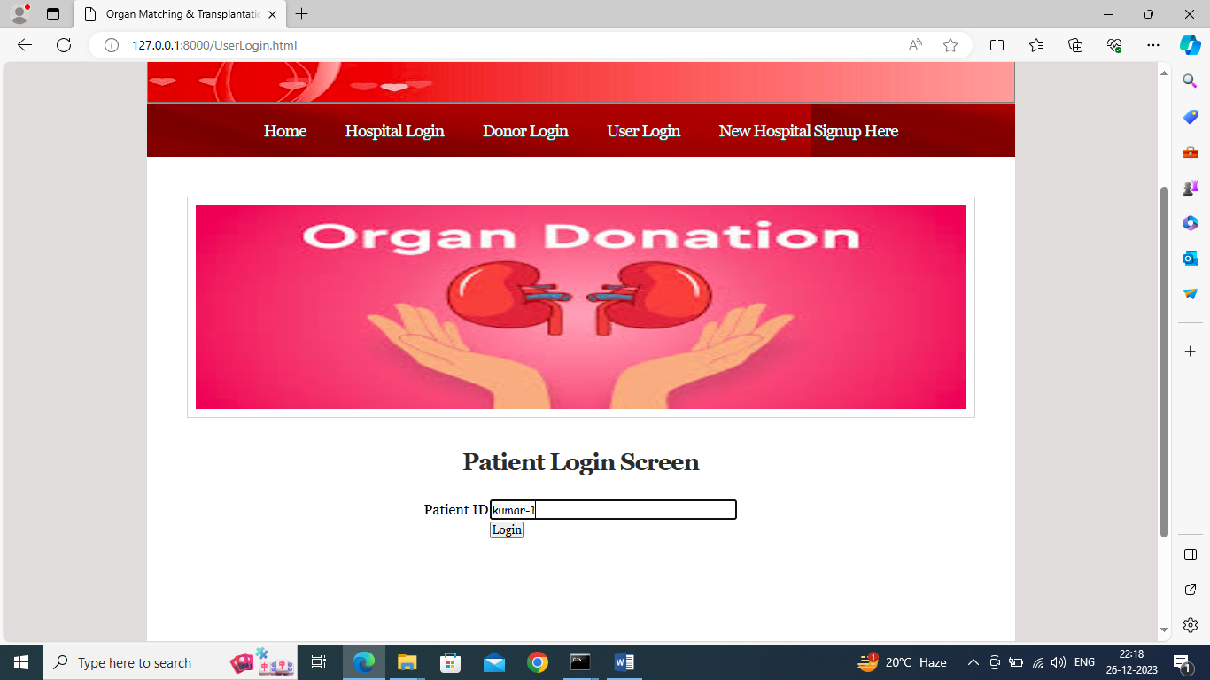

In above screen patient is login and after login will get below page

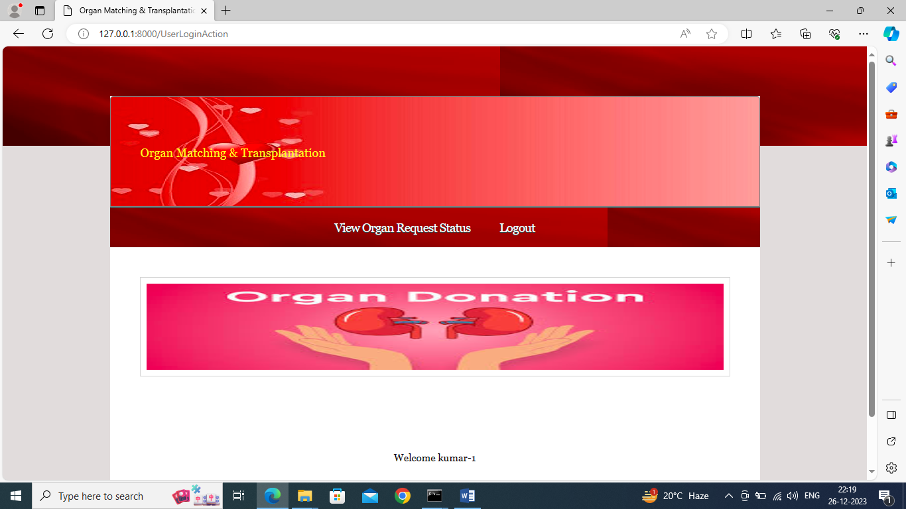

In above screen patient can click on ‘View Organ Request Status’ to view status of his organ request

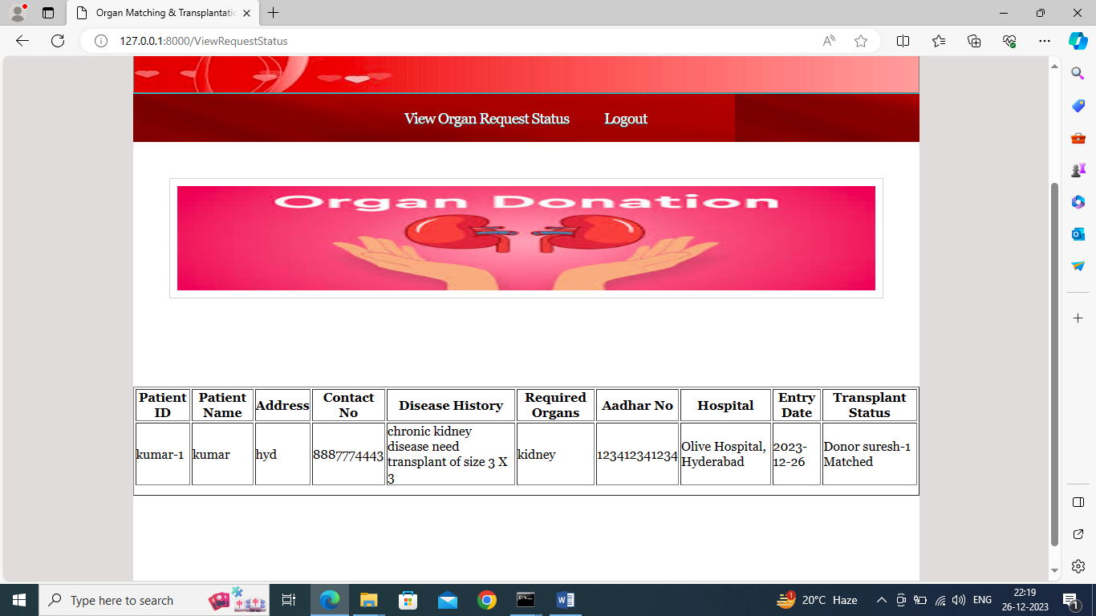

In above screen patient or user can view which donor organ matched with his request and all users and donors can view above alert once hospital matched them.

Similarly by following above screens you can save all details in Blockchain